

Inventory Tool How-To

2026 Colorado Wildfires

Bevel Inventory Tool How-To
2026 Colorado Wildfires

**Please refer to United Policyholders for specific insurance information
regarding the 2026 Colorado Wildfires**

Who we are

Our co-founder's family home stood for nearly 50 years in Pacific Palisades. When it burned in the 2025 LA fires, the hardest part wasn't just the loss; it was trying to remember and document everything that was inside.

Rebuilding a personal property inventory from memory is exhausting, emotional, and error-prone. From what we’ve observed, most families significantly underestimate what they have. That means they settle for less than they're owed.

We built Bevel so that no one has to go through that process alone. Our free web app helps you reconstruct your inventory faster, more completely, and with less stress — so you can focus on what matters most: moving forward.

What Bevel does

Bevel’s AI identifies and prices items from photos, videos, and receipts. Our goal is to help you complete and submit your inventory list as fast as possible so that you can get a head start on moving back home. How you use the Inventory Tool depends on the extent of damage to your home. This manual will teach you how to use Bevel whether you have a) Total Loss, b) Partial Loss, or c) Smoke Damage.

Table of Contents

Basic Set-up and Functions 3
Inventory Suggestions: Total Loss 5
Inventory Suggestions: Partial Loss 6
Inventory Suggestions: Smoke Damage 7
Frequently Asked Questions 8

Basic Set-up and Functions

- Create a free account at inventory.bevelmade.com

- Upload photos, videos, and receipts, and Bevel will extract item names and estimated prices. Jog your memory with AI-suggested items for each room. 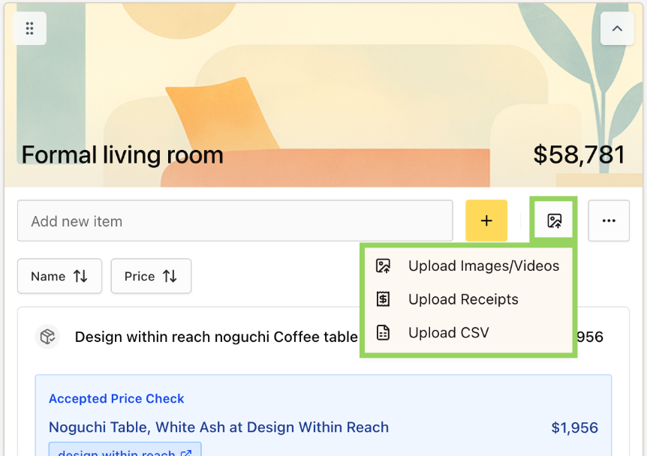

- Review the generated item list:
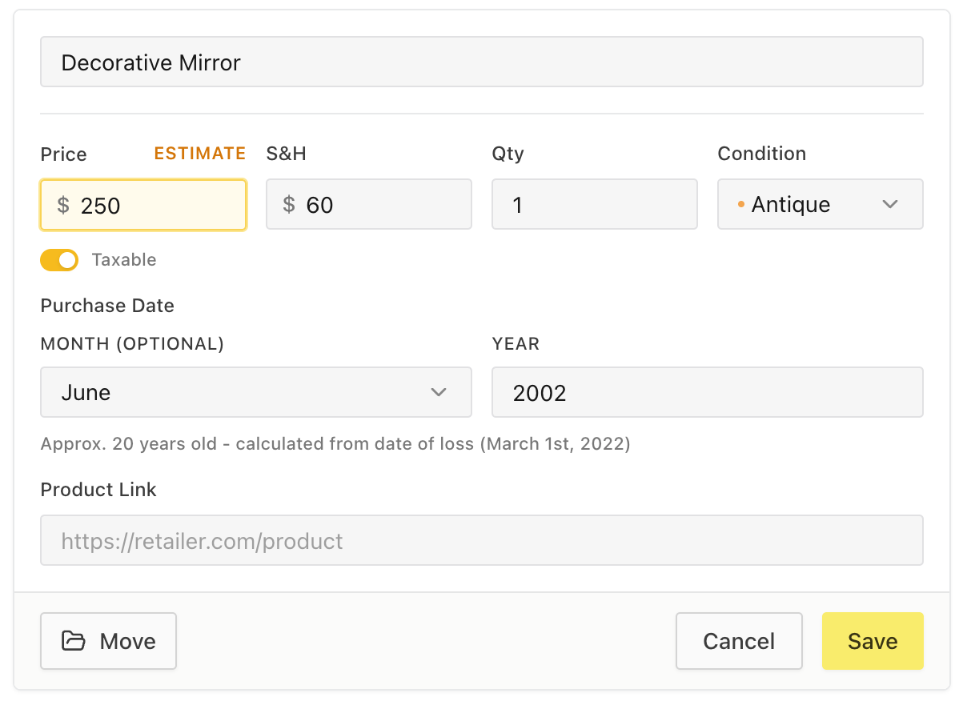
  - Edit names if needed to be more specific (e.g., “Samsung 55” TV”, “IKEA Mydal bunk bed”).
  - Edit quantities when applicable.
  - Add information about age, condition, and shipping & handling costs.
  - Add missing items manually.
- When you’ve completed your list, export it to Excel and submit it to your adjuster. You can export as many times as you need.

Inventory Suggestions: Total Loss
Home was completely burned down.

- After setting up a free Bevel account, collect photos from family, friends, and anyone else who may have documented your home and the items in it. Even a Christmas family photo will do – Bevel skips over people and pets.

- Set up “rooms” in Bevel to organize contents. Bevel’s open format allows you to organize by room, category, or however is easiest for you.

- Upload photos, videos, and receipts room by room. *Please note wifi or cellular service is required to upload attachments*

- AI can make mistakes: check for and delete any duplicates.

Inventory Suggestions: Partial Loss
Home was partially burned down – some rooms and items may remain but may be smoke damaged.

- Before debris is removed, take a 1 minute video of each room in your house (shorter videos are easier to process).
  - Take videos slowly. If you can’t see an item because the video was blurred, Bevel’s AI won’t be able to, either.
  - For closets, we recommend flipping through each item of clothing and reading out the label – Bevel will pick up on audio, too.

- Anywhere you see an item with a brand name or serial number, take a picture of it. These details help Bevel find the most accurate prices for your items, and are objective evidence of ownership for your adjuster.

- Assemble any additional old photos or videos of items that were lost.

- Create “rooms” in Bevel for each room of your house, and upload photos, videos, and receipts room by room. *Please note wifi or cellular service is required to upload attachments. Take all photos and videos on your phone or camera, and upload to Bevel in an area with stable internet connection*

- AI can make mistakes: check for and delete any duplicates.

Inventory Suggestions: Smoke Damage
Home was not burned, but was damaged by severe smoke – items are still remaining, but may or may not be usable.

- Before debris is removed or smoke-damaged items are thrown away, take a 1 minute video of each room in your house (shorter videos are easier to process).
  - Take videos slowly. If you can’t see an item because the video was blurred, Bevel’s AI won’t be able to, either.
  - For closets, we recommend flipping through each item of clothing and reading out the label – Bevel will pick up on audio, too.

- Anywhere you see an item with a brand name or serial number, take a picture of it. These details help Bevel find the most accurate prices for your items.

- Create “rooms” in Bevel for each room of your house, and upload photos, videos, and receipts room by room. *Please note wifi or cellular service is required to upload attachments. Take all photos and videos on your phone or camera, and upload to Bevel in an area with stable internet connection*

- AI can make mistakes: check for and delete any duplicates.

Frequently Asked Questions

What format is the Bevel spreadsheet exported in?
Bevel will export your spreadsheet to an XLS file, which is importable by most apps including Excel, Numbers, and Google Sheets.

How much does it cost?
Nothing! Bevel’s web inventory tool will always be free for disaster survivors.

Where can I see more detailed tutorials?
Check out our our YouTube @bevel_made for more detailed videos about how to use Bevel. Here is a link to our how-to playlist: https://www.youtube.com/playlist?list=PLQ8MC5EQ6Btim54I39J2EPXDaTCk1PDK4

Who do I contact if I’m having trouble or running into issues?
Reach out to info@bevelmade.com and we will get back to you as soon as possible.

Can Bevel price my renovation or home structure?
No, Bevel only works for contents. Anything that if you turned your home upside down would fall out of it.

Does Bevel have an offline mode?
No, Bevel’s inventory tool is hosted on the web and requires internet access to edit. If you are taking photos or videos of a home in an area that does not have cell reception or wifi, wait until you are in an area with reliable internet to upload onto Bevel.

Does Bevel work on the phone?
Yes, the Bevel Inventory Tool can be accessed from a smartphone. However, please only upload attachments in areas with reliable service.

**For any other FAQs, please reference our website at bevelmade.com/faqs**

